Taller Agregaciones
  - Santiago Velandia

Ejercicios de práctica
- Obtener la cantidad de empleados de la veterinaria agrupados por género y ordenarlos de menor a mayor.

- Entrada -> $group -> $sort -> Salida
- Etapa 1. Usa $group por el campo "gender", y se suma la cantidad usando la función $sum
Etapa 2. Usa $sort, pasandole "1" para indicar que es ascendente
- db.employee.aggregate([
{ $group: {_id: "$gender", "cantidad": {$sum: 1}}},
{ $sort: {"cantidad": 1}}
])

- Identificar cuantos auxiliares de estética hay por género y organizarlos de forma ascendente por el género.

- Entrada -> $match -> $group -> $sort -> Salida
- Etapa 1. Usa $match para encontrar "Auxiliar de estética"
Etapa 2. Usa $group para agrupar por género
Etapa 3. Usa $sort sobre el campo 'gender' y se le pasa "1" para indicar que es ascendente
- db.employee.aggregate([
{ $match: "Auxiliar de estética" },
{ $group: {_id: "$gender", "cantidad": {$sum: 1}}},
{ $sort: {gender: 1}}])

- Calcular el total de la nómina de los empleados por cargo y ordenar alfabéticamente por cargo.

- Entrada -> $group -> $sort -> Salida
- Etapa 1. Agrupa con $group por cargo y calcula la suma de los salarios
Etapa 2. Ordena con $sort sobre cargo y ordena ascendentemente (A-Z)
- db.employee.aggregate([
{ $group : {_id: "$jobtitle", "total": {$sum: "$salario"}} },
{ $sort : {jobtitle: 1} }])

- Calcular el total de la nómina de los empleados por cargo y mostrar solo los que superen los 5 millones de pesos

- Entrada -> $group -> $gt -> Salida
- Etapa 1. Agrupa con $group por cargo y calcula el total de nómina Etapa 2. Filtra con $gt par a los que superen el total de 5000000
- db.employee.aggregate([
{ $group : {_id: "$jobtitle", "total": {$sum: "$salario"}} },
{ $match: { "total": { $gt: 5000000 } } }])

Reto de aplicación

Para este, tenemos que imaginarnos todos que existe un corredores.json y que sobre eso es que funcionan estas cosas, ¿vale?
- Identificar total de minutos y total de kilómetros recorridos por cada usuario (investigue cómo concatenar nombre y apellido) de la aplicación running
- Entrada $group Salida
- db.runs.aggregate([
{
$group: {
_id: { $concat: ["$user.firstname", " ", "$user.lastname"] },
totalMinutes: { $sum: "$minutes" },
totalKilometers: { $sum: "$kilometers" }
}
}])
- 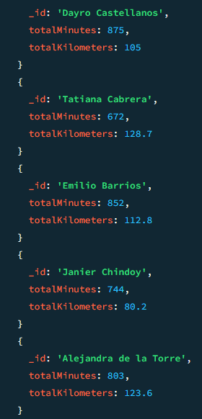

- Obtener el promedio de minutos mensuales realizados por cada corredor
- Entrada $group $group Salida
- db.runs.aggregate([
{
$group: {
_id: { user: { $concat: ["$user.firstname", " ", "$user.lastname"] }, month: "$month" },
mensuales: { $avg: "$minutes" }
}
},
{
$group: {
_id: "$_id.user",
avgMensual: { $avg: "$mensuales" }
}
}])
- 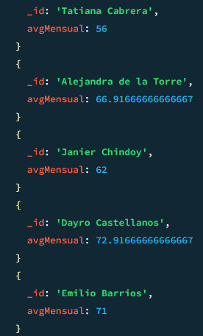

- Obtener el promedio de kilómetros mensuales de cada corredor, siempre y cuando ése promedio sea mayor a 5K
- Entrada $group $group $match Salida
- db.runs.aggregate([
{
$group: {
_id: { user: { $concat: ["$user.firstname", " ", "$user.lastname"] }, month: "$month" },
mensualKm: { $avg: "$kilometers" }
}
},
{
$group: {
_id: "$_id.user",
avgMensualKm: { $avg: "$mensualKm" }
}
},
{ $match: { avgMensualKm: { $gt: 5 } } }])
- 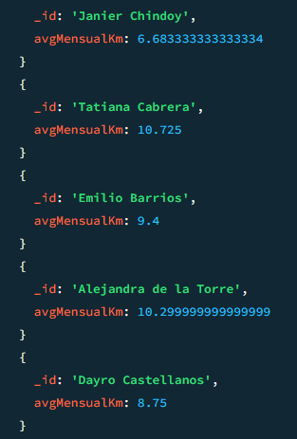

- Obtener el total de kilómetros recorridos agrupados por corredor y por mes (investigar cómo se puede agrupar por dos campos), ordenar por me5K
- Entrada $group $sort Salida
- db.runs.aggregate([
{
$group: {
_id: {
user: { $concat: ["$user.firstname", " ", "$user.lastname"] },
month: "$month"
},
totalKm: { $sum: "$kilometers" }
}
},
{ $sort: { "_id.month": 1 } }])
- 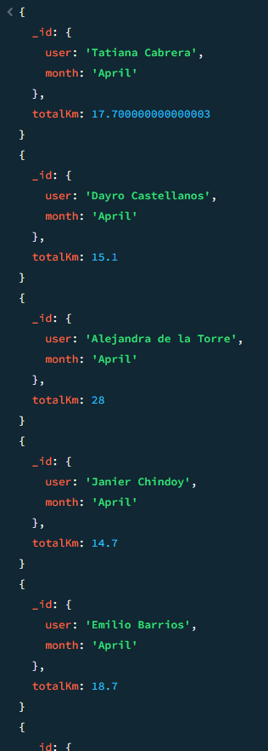

- Ver por cada corredor las distancias recorridas (investigar uso de operador $addToSet)
- Entrada $group Salida
- db.runs.aggregate([
{
$group: {
_id: { $concat: ["$user.firstname", " ", "$user.lastname"] },
distances: { $addToSet: "$kilometers" }
}
}])
- 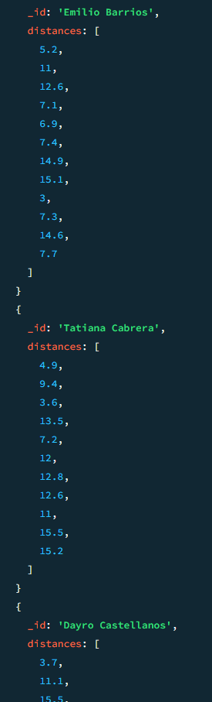

- Determinar cuántos corredores están interesados en cada afición (investigar uso $unwind)
- Entrada $unwind $group Salida
- db.users.aggregate([
{ $unwind: "$hobbies" },
{
$group: {
_id: "$hobbies",
total: { $sum: 1 }
}
}])
- 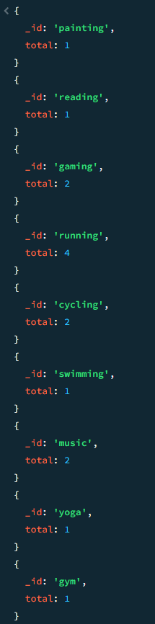

- Me da muchísima pereza hacer este.
JSON runs.json:
{"_id": 1, "user": {"userId": 1, "firstname": "Tatiana", "lastname": "Cabrera"}, "month": "January", "minutes": 32, "kilometers": 13.5, "date": "2026-01-14"}
{"_id": 2, "user": {"userId": 1, "firstname": "Tatiana", "lastname": "Cabrera"}, "month": "January", "minutes": 75, "kilometers": 7.2, "date": "2026-01-02"}
{"_id": 3, "user": {"userId": 1, "firstname": "Tatiana", "lastname": "Cabrera"}, "month": "February", "minutes": 39, "kilometers": 3.6, "date": "2026-02-01"}
{"_id": 4, "user": {"userId": 1, "firstname": "Tatiana", "lastname": "Cabrera"}, "month": "February", "minutes": 58, "kilometers": 12.6, "date": "2026-02-07"}
{"_id": 5, "user": {"userId": 1, "firstname": "Tatiana", "lastname": "Cabrera"}, "month": "March", "minutes": 30, "kilometers": 9.4, "date": "2026-03-19"}
{"_id": 6, "user": {"userId": 1, "firstname": "Tatiana", "lastname": "Cabrera"}, "month": "March", "minutes": 58, "kilometers": 12.0, "date": "2026-03-03"}
{"_id": 7, "user": {"userId": 1, "firstname": "Tatiana", "lastname": "Cabrera"}, "month": "April", "minutes": 41, "kilometers": 12.8, "date": "2026-04-12"}
{"_id": 8, "user": {"userId": 1, "firstname": "Tatiana", "lastname": "Cabrera"}, "month": "April", "minutes": 58, "kilometers": 4.9, "date": "2026-04-03"}
{"_id": 9, "user": {"userId": 1, "firstname": "Tatiana", "lastname": "Cabrera"}, "month": "May", "minutes": 67, "kilometers": 11.0, "date": "2026-05-05"}
{"_id": 10, "user": {"userId": 1, "firstname": "Tatiana", "lastname": "Cabrera"}, "month": "May", "minutes": 67, "kilometers": 15.5, "date": "2026-05-25"}
{"_id": 11, "user": {"userId": 1, "firstname": "Tatiana", "lastname": "Cabrera"}, "month": "June", "minutes": 48, "kilometers": 15.2, "date": "2026-06-20"}
{"_id": 12, "user": {"userId": 1, "firstname": "Tatiana", "lastname": "Cabrera"}, "month": "June", "minutes": 99, "kilometers": 11.0, "date": "2026-06-15"}
{"_id": 13, "user": {"userId": 2, "firstname": "Dayro", "lastname": "Castellanos"}, "month": "January", "minutes": 101, "kilometers": 15.5, "date": "2026-01-19"}
{"_id": 14, "user": {"userId": 2, "firstname": "Dayro", "lastname": "Castellanos"}, "month": "January", "minutes": 39, "kilometers": 13.8, "date": "2026-01-02"}
{"_id": 15, "user": {"userId": 2, "firstname": "Dayro", "lastname": "Castellanos"}, "month": "February", "minutes": 56, "kilometers": 11.1, "date": "2026-02-18"}
{"_id": 16, "user": {"userId": 2, "firstname": "Dayro", "lastname": "Castellanos"}, "month": "February", "minutes": 92, "kilometers": 3.7, "date": "2026-02-13"}
{"_id": 17, "user": {"userId": 2, "firstname": "Dayro", "lastname": "Castellanos"}, "month": "March", "minutes": 75, "kilometers": 11.3, "date": "2026-03-16"}
{"_id": 18, "user": {"userId": 2, "firstname": "Dayro", "lastname": "Castellanos"}, "month": "March", "minutes": 90, "kilometers": 8.6, "date": "2026-03-16"}
{"_id": 19, "user": {"userId": 2, "firstname": "Dayro", "lastname": "Castellanos"}, "month": "April", "minutes": 107, "kilometers": 10.6, "date": "2026-04-22"}
{"_id": 20, "user": {"userId": 2, "firstname": "Dayro", "lastname": "Castellanos"}, "month": "April", "minutes": 36, "kilometers": 4.5, "date": "2026-04-12"}
{"_id": 21, "user": {"userId": 2, "firstname": "Dayro", "lastname": "Castellanos"}, "month": "May", "minutes": 61, "kilometers": 6.4, "date": "2026-05-17"}
{"_id": 22, "user": {"userId": 2, "firstname": "Dayro", "lastname": "Castellanos"}, "month": "May", "minutes": 42, "kilometers": 3.2, "date": "2026-05-23"}
{"_id": 23, "user": {"userId": 2, "firstname": "Dayro", "lastname": "Castellanos"}, "month": "June", "minutes": 68, "kilometers": 7.3, "date": "2026-06-22"}
{"_id": 24, "user": {"userId": 2, "firstname": "Dayro", "lastname": "Castellanos"}, "month": "June", "minutes": 108, "kilometers": 9.0, "date": "2026-06-23"}
{"_id": 25, "user": {"userId": 3, "firstname": "Emilio", "lastname": "Barrios"}, "month": "January", "minutes": 108, "kilometers": 7.1, "date": "2026-01-24"}
{"_id": 26, "user": {"userId": 3, "firstname": "Emilio", "lastname": "Barrios"}, "month": "January", "minutes": 35, "kilometers": 6.9, "date": "2026-01-09"}
{"_id": 27, "user": {"userId": 3, "firstname": "Emilio", "lastname": "Barrios"}, "month": "February", "minutes": 98, "kilometers": 12.6, "date": "2026-02-06"}
{"_id": 28, "user": {"userId": 3, "firstname": "Emilio", "lastname": "Barrios"}, "month": "February", "minutes": 46, "kilometers": 15.1, "date": "2026-02-05"}
{"_id": 29, "user": {"userId": 3, "firstname": "Emilio", "lastname": "Barrios"}, "month": "March", "minutes": 107, "kilometers": 7.4, "date": "2026-03-06"}
{"_id": 30, "user": {"userId": 3, "firstname": "Emilio", "lastname": "Barrios"}, "month": "March", "minutes": 69, "kilometers": 14.9, "date": "2026-03-13"}
{"_id": 31, "user": {"userId": 3, "firstname": "Emilio", "lastname": "Barrios"}, "month": "April", "minutes": 41, "kilometers": 11.0, "date": "2026-04-13"}
{"_id": 32, "user": {"userId": 3, "firstname": "Emilio", "lastname": "Barrios"}, "month": "April", "minutes": 30, "kilometers": 7.7, "date": "2026-04-27"}
{"_id": 33, "user": {"userId": 3, "firstname": "Emilio", "lastname": "Barrios"}, "month": "May", "minutes": 71, "kilometers": 3.0, "date": "2026-05-15"}
{"_id": 34, "user": {"userId": 3, "firstname": "Emilio", "lastname": "Barrios"}, "month": "May", "minutes": 82, "kilometers": 7.3, "date": "2026-05-02"}
{"_id": 35, "user": {"userId": 3, "firstname": "Emilio", "lastname": "Barrios"}, "month": "June", "minutes": 77, "kilometers": 5.2, "date": "2026-06-15"}
{"_id": 36, "user": {"userId": 3, "firstname": "Emilio", "lastname": "Barrios"}, "month": "June", "minutes": 88, "kilometers": 14.6, "date": "2026-06-17"}
{"_id": 37, "user": {"userId": 4, "firstname": "Alejandra", "lastname": "de la Torre"}, "month": "January", "minutes": 71, "kilometers": 8.0, "date": "2026-01-09"}
{"_id": 38, "user": {"userId": 4, "firstname": "Alejandra", "lastname": "de la Torre"}, "month": "January", "minutes": 76, "kilometers": 7.4, "date": "2026-01-12"}
{"_id": 39, "user": {"userId": 4, "firstname": "Alejandra", "lastname": "de la Torre"}, "month": "February", "minutes": 39, "kilometers": 6.9, "date": "2026-02-22"}
{"_id": 40, "user": {"userId": 4, "firstname": "Alejandra", "lastname": "de la Torre"}, "month": "February", "minutes": 97, "kilometers": 7.7, "date": "2026-02-23"}
{"_id": 41, "user": {"userId": 4, "firstname": "Alejandra", "lastname": "de la Torre"}, "month": "March", "minutes": 43, "kilometers": 9.2, "date": "2026-03-04"}
{"_id": 42, "user": {"userId": 4, "firstname": "Alejandra", "lastname": "de la Torre"}, "month": "March", "minutes": 83, "kilometers": 13.6, "date": "2026-03-16"}
{"_id": 43, "user": {"userId": 4, "firstname": "Alejandra", "lastname": "de la Torre"}, "month": "April", "minutes": 35, "kilometers": 14.6, "date": "2026-04-09"}
{"_id": 44, "user": {"userId": 4, "firstname": "Alejandra", "lastname": "de la Torre"}, "month": "April", "minutes": 92, "kilometers": 13.4, "date": "2026-04-07"}
{"_id": 45, "user": {"userId": 4, "firstname": "Alejandra", "lastname": "de la Torre"}, "month": "May", "minutes": 27, "kilometers": 11.8, "date": "2026-05-03"}
{"_id": 46, "user": {"userId": 4, "firstname": "Alejandra", "lastname": "de la Torre"}, "month": "May", "minutes": 43, "kilometers": 13.4, "date": "2026-05-09"}
{"_id": 47, "user": {"userId": 4, "firstname": "Alejandra", "lastname": "de la Torre"}, "month": "June", "minutes": 100, "kilometers": 3.2, "date": "2026-06-06"}
{"_id": 48, "user": {"userId": 4, "firstname": "Alejandra", "lastname": "de la Torre"}, "month": "June", "minutes": 97, "kilometers": 14.4, "date": "2026-06-14"}
{"_id": 49, "user": {"userId": 5, "firstname": "Janier", "lastname": "Chindoy"}, "month": "January", "minutes": 103, "kilometers": 8.7, "date": "2026-01-08"}
{"_id": 50, "user": {"userId": 5, "firstname": "Janier", "lastname": "Chindoy"}, "month": "January", "minutes": 34, "kilometers": 7.8, "date": "2026-01-14"}
{"_id": 51, "user": {"userId": 5, "firstname": "Janier", "lastname": "Chindoy"}, "month": "February", "minutes": 37, "kilometers": 15.2, "date": "2026-02-12"}
{"_id": 52, "user": {"userId": 5, "firstname": "Janier", "lastname": "Chindoy"}, "month": "February", "minutes": 67, "kilometers": 5.9, "date": "2026-02-16"}
{"_id": 53, "user": {"userId": 5, "firstname": "Janier", "lastname": "Chindoy"}, "month": "March", "minutes": 107, "kilometers": 3.2, "date": "2026-03-07"}
{"_id": 54, "user": {"userId": 5, "firstname": "Janier", "lastname": "Chindoy"}, "month": "March", "minutes": 30, "kilometers": 4.6, "date": "2026-03-14"}
{"_id": 55, "user": {"userId": 5, "firstname": "Janier", "lastname": "Chindoy"}, "month": "April", "minutes": 71, "kilometers": 4.8, "date": "2026-04-27"}
{"_id": 56, "user": {"userId": 5, "firstname": "Janier", "lastname": "Chindoy"}, "month": "April", "minutes": 30, "kilometers": 9.9, "date": "2026-04-12"}
{"_id": 57, "user": {"userId": 5, "firstname": "Janier", "lastname": "Chindoy"}, "month": "May", "minutes": 99, "kilometers": 8.7, "date": "2026-05-25"}
{"_id": 58, "user": {"userId": 5, "firstname": "Janier", "lastname": "Chindoy"}, "month": "May", "minutes": 78, "kilometers": 3.1, "date": "2026-05-20"}
{"_id": 59, "user": {"userId": 5, "firstname": "Janier", "lastname": "Chindoy"}, "month": "June", "minutes": 38, "kilometers": 5.2, "date": "2026-06-09"}
{"_id": 60, "user": {"userId": 5, "firstname": "Janier", "lastname": "Chindoy"}, "month": "June", "minutes": 50, "kilometers": 3.1, "date": "2026-06-16"}

users.json
{"userId": 1, "firstname": "Tatiana", "lastname": "Cabrera", "gender": "F", "hobbies": ["running", "cycling", "gaming"]}
{"userId": 2, "firstname": "Dayro", "lastname": "Castellanos", "gender": "M", "hobbies": ["yoga", "running", "reading"]}
{"userId": 3, "firstname": "Emilio", "lastname": "Barrios", "gender": "M", "hobbies": ["swimming", "cycling", "music"]}
{"userId": 4, "firstname": "Alejandra", "lastname": "de la Torre", "gender": "F", "hobbies": ["running", "painting", "music"]}
{"userId": 5, "firstname": "Janier", "lastname": "Chindoy", "gender": "M", "hobbies": ["gym", "gaming", "running"]}

